ICS 474 Big Data Analytics
HW2

Student Name: Renad Sultan Alqahtani
ID: 202169930
Email: s202169930@kfupm.edu.sa

- Extract relevant entities from the given requirement statement.
Entity | Description | Attributes
Member | Member’s Info, who are registered in the library | MemberID, MemberName, Email, Phone
Book | Books details | BookID, BookTitle, Genre
Author | Authors Info | AuthorID, AuthorName,
Borrow | Borrowing operations | BorrowID, BorrowDate, BookID, DueDate, ReturnDate, MemberID
Reservation | Reservation operation | ReservationID, ReservationDate, ReservationStatus, MemberID, BookID

- Show the relationships between entities by specifying cardinality between pairs of entities using a table (see working example in Lecture 11, slide 11).
 | Member | Book | Borrow | Reservation | Author
Member |  |  | M:1 | M:1
Book |  |  | M:1 | M:1 | M:n
Borrow | M:1 | M:1
Reservation | M:1 | M:1
Author |  | M:n

- Derive a relational database schema (in the form of an ERD diagram) where the relations are normalised to 3NF. Show the derivation of the 3NF by including the 1NF and 2NF in the report.
- UNF:
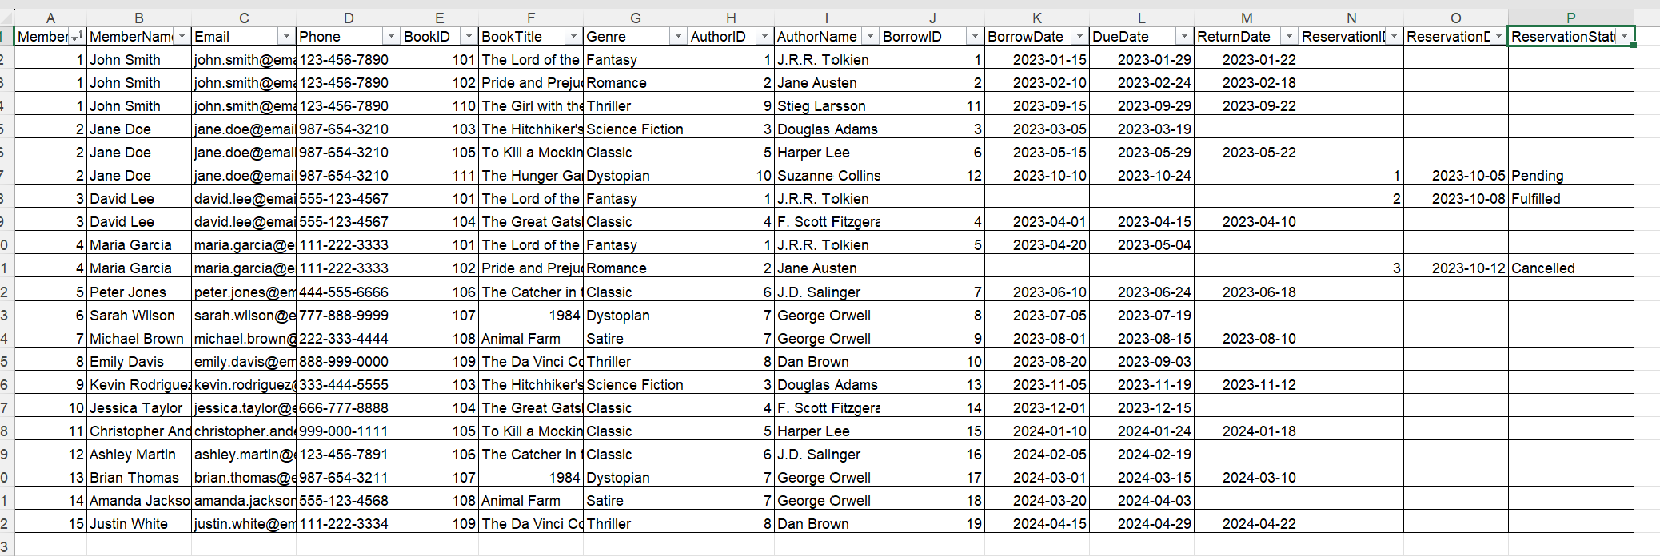

UNF problems:
1-Duplicate member and book data across multiple rows.
2-The same book appears with multiple authors.
3-"Genre" is a duplicate text value in more than one row.

- 1NF:
Each column must contain atomic values.
I separate the data into logical entities:
- Member (MemberID, MemberName, Email, Phone) ->Each member appears once, uniquely identified by MemberID.
- Book (BookID, BookTitle, Genre) -> Each book is stored once with its title and genre.
- Author (AuthorID, AuthorName)-> Each author appears once.
- Borrow (BorrowID, MemberID, BookID, BorrowDate, DueDate, ReturnDate)
->Each borrowing transaction has one record.
- Reservation (ReservationID, MemberID, BookID, ReservationDate, ReservationStatus) -> Each reservation is stored as one record.
- BookAuthor (BookID, AuthorID) -> A linking table that represents many-to-many relationship between authors and books.

Now all the data is atomic and no repeating

- 2NF:
- An entity is in second normal form (2NF) if it is already in 1NF and if the values of all non-primary key attributes are dependent on the full primary key - not just part of it–No part-key dependencie.

- There is only one composite key, BookAuthor (BookID, AuthorID)

- There are no non-primary key attributes in this BookAuthor table, so there are no partial dependencies exist.

- All other tables have only 1 primary keys, so it is satisfy 2NF

- 3NF:
An entity is in third normal form (3NF) if it is already in 2NF and if the values of its non-primary key attributes are not dependent on any other non-primary key attributes–No transitive/non-key dependencies.
So, I must remove transitive dependencies,
The attributes “Genre” In the book table depends on the “BookID”, and the gere value repeats across books.

Now, I should create new table Genre(GenreID, GenreName)

Updete on tables:
Genre(GenreID, GenreName)
Book (BookID, BookTitle, GenreID), GenreID is foreign key from Genre table

- ERD diagram:
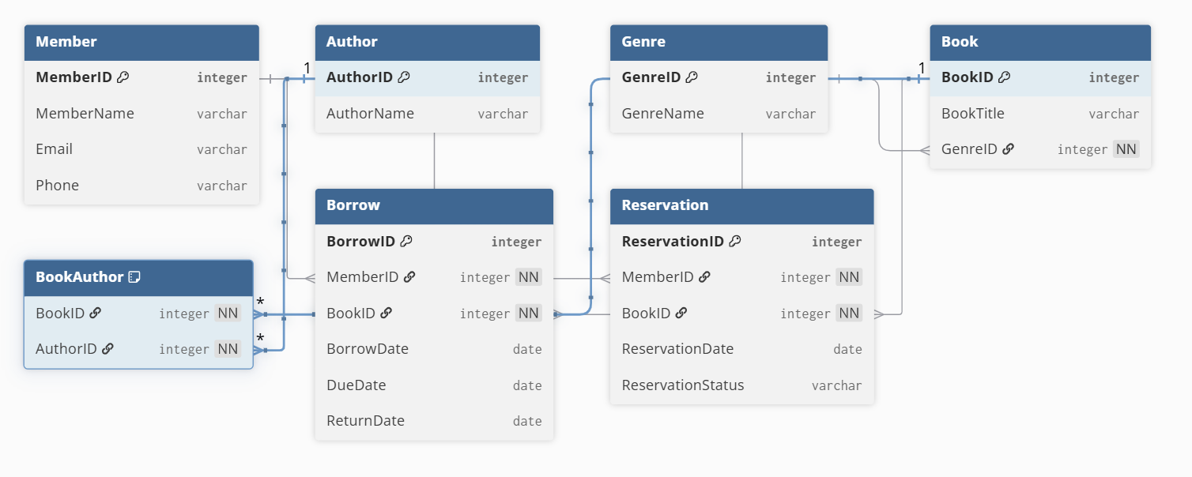

- Write the database schema/structure derived from the above ERD using textual notation in the form Entity_Name(Attribute1_Name, …), where the constraints, such as primary keys and foreign keys, are appropriately identified.
- Member (MemberID PK, MemberName, Email, Phone)
- Book (BookID PK, BookTitle, GenreID FK)
- Author (AuthorID PK, AuthorName)
- Borrow (BorrowID PK, MemberID FK -> Member, BookID FK -> Book, BorrowDate, DueDate, ReturnDate)
- Reservation (ReservationID PK, MemberID FK -> Member, BookID FK ->Book, ReservationDate, ReservationStatus)
- BookAuthor (BookID FK -> Book, AuthorID FK -> Author, PK(BookID, AuthorID))
- Genre(GenreID PK, GenreName UNIQUE)
- Write SQL statements to CREATE all the tables with the constraints identified in the previous question. (2x6 = 12 Marks)
- Write SQL statements to INSERT ALL data from the unnormalised data table (provided in the Excel file) into the created tables.
- Write SQL queries to SELECT the content of each table.
- Write a SQL query to SELECT borrowing information along with member and book details (BorrowID, MemberName, BookTitle, BorrowDate, DueDate, and ReturnDate) from the database using a JOIN statement.

https://sqlfiddle.com/oracle/online-compiler?id=978869d8-113f-4d36-b671-64e0ec089936

